IEC 61386 – and what it means

In 1995/96 the new European standards for Flexible & Pliable Conduit systems BS EN 50086-2-3 and BS EN 50086-2-2 were published by BSI. This was the first European standard for Flexible & Pliable Conduit systems:

The standard is complementary to the Wiring Regulations BS7671 (1992) under which it is listed. In addition it was written with statutory obligations under the Electricity at Work legislation in mind. Proof of conformity with the standard is valuable in the technical file for CE Marking.

The standard was written to conform to the Low Voltage Directive (LVD) and with the Essential Requirements of the Construction Products Directive (CPD) in mind.
As required by the CENELEC rules it was written in the style of a performance standard.

In November 2004 this standard was superceded by the new IEC61386 parts 1, 2.2 (pliable conduit) and 2.3 (flexible conduit). This is essentially the same standard but with some improvement and updates to the impact and fire testing. EN50086 remains in force until August 2007 when it will be fully replaced by IEC61386. IEC61386 is now live and all conduit manufacturers should be testing and certifying to the new standard.

There are few references to dimensions in the standard. The standard identifies key product characteristics such as: mechanical strength, temperature, electrical properties, resistance to ingress of solids and water, corrosion resistance and fire performance.

For each of these characteristics there are recommended tests as well as a range of performances. The purchaser must decide which performance against each characteristic is appropriate for his installation.

Mechanical properties

The mechanical properties of flexible and pliable conduit include resistance to compression, resistance to impact, tensile (pull-off) strength, flexing (flexible conduit) and bending (pliable conduit).
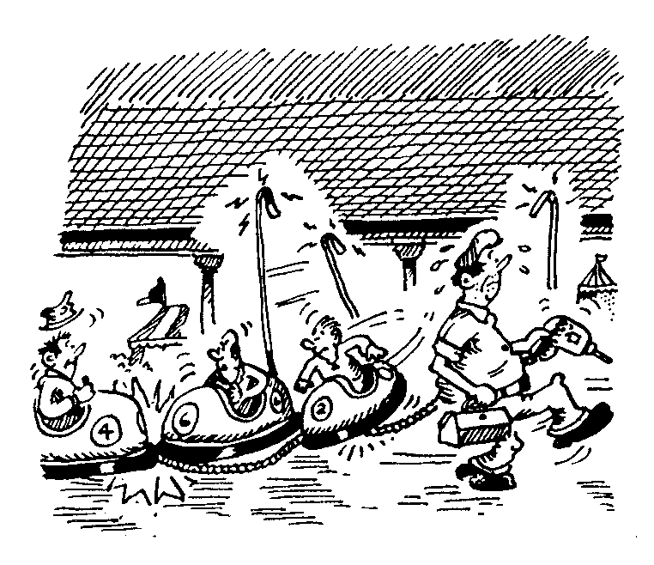
COMPRESSION AND IMPACT RESISTANCE

All conduits in exposed situations can he subject to crushing, for example moving parts of a machine, or moving machines such as fork lift trucks, cleaning machines, mobile maintenance trucks etc can crush the conduit against a wall, on the floor or even against the machine to which the conduit may be fitted.
For this reason the standard includes a test for compression with a 5 point scale as well as an impact test, also with a 5 point scale from which the specifier/purchaser can select his required performance.

Note: The impact performance results from selections of impact energy (five point scale) AND low temperature (also a five point scale). A range of combinations is possible.

IMPACT STRENGTH
As a general rule ‘medium’ or medium heavy’ (classes 3 or 4) should be specified where the conduit is to be installed unprotected in machine shops or on factory floors. Indeed for unprotected conduit in hospitals, school workshops/laboratories, and in offices the specifier would be wise to make equally stringent requirements. The risk of severe crushing may seem slight, however, when it does happen it may lead to damage to the cables inside the conduit with consequential systems failure, downtime whilst repairs are effected, and replacement of the cabling and conduit.
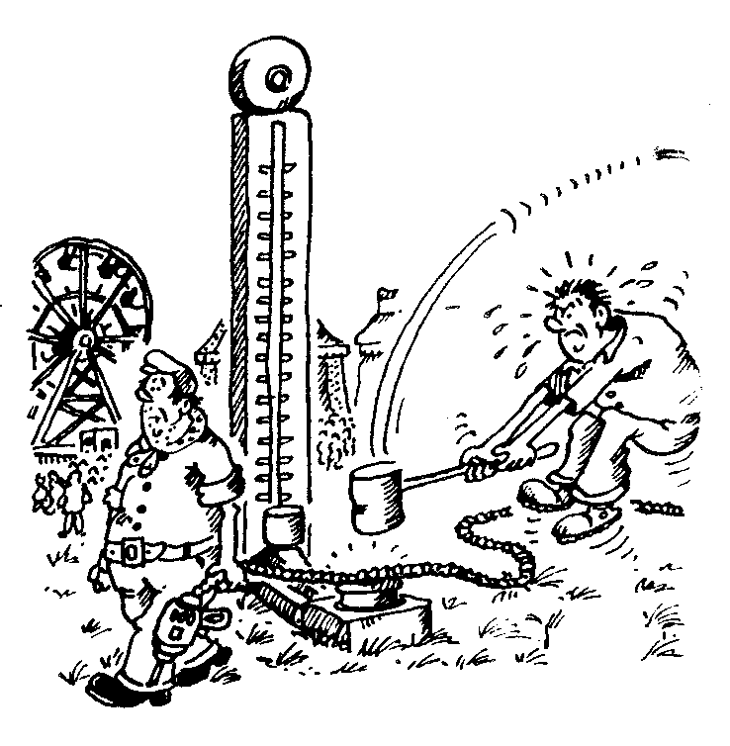

The very light, light and medium strength products will be appropriate where there is secondary protection, for instance inside a cavity wall, beneath a suspended floor or perhaps in an elevated position outside the reach of maintenance or transporting machinery.

COMPRESSION STRENGTH

The problems associated with impact are broadly similar to those of compression. Impact caused by a falling object will damage the conduit and may result in cable damage and system failure.
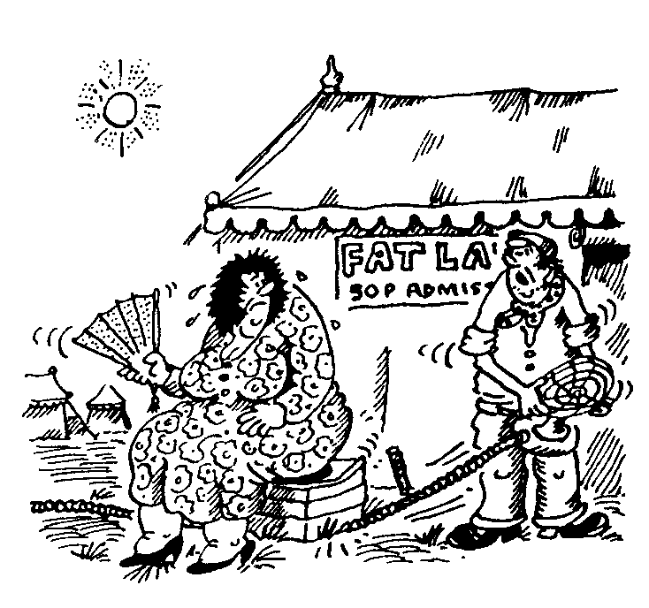

As with compression, specifiers/purchasers are advised to purchase medium and heavy impact strength for conduit in exposed situations. In factories, workshops etc. there is a constant risk of falling objects often with sharp edges or with mobile machinery such as fork lift trucks. In hospitals, schools, offices and other public buildings impact may be due to falling delivery packages, gas cylinders or furniture, and mobile equipment such as cleaning equipment.
The potential costs are the same as for compression: replacement of damaged products, system failure and down time’. The very light and light protection products are best used where the conduit has secondary protection

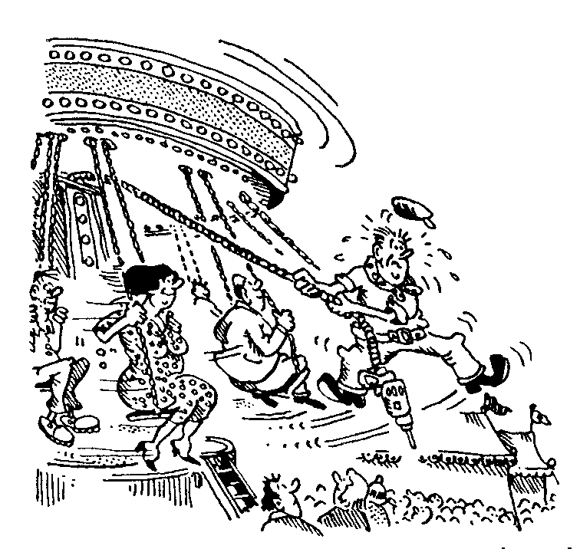
TENSILE STRENGTH

Generally flexible and pliable conduit does not offer a high degree of tensile strength. However there is a need to measure pull off resistance. For this purpose the test for these products has a minimum requirement for 100 Newtons (10 kilos> Higher performance is possible and can be specified.

TEMPERATURE

Since relatively high and low temperatures will affect the performance of flexible and pliable conduit, tests and charts have been included in the standard. Temperature performance characteristics will be of obvious importance according to the climate of the country in which the product is used, especially where used externally or in unheated/cooled buildings. In addition in aircraft, for example, both absolute temperatures and ‘chill factors’ will need to be taken into account. Indeed chill factors will affect performance on trains, buses, commercial vehicles, cars and ships/boats.
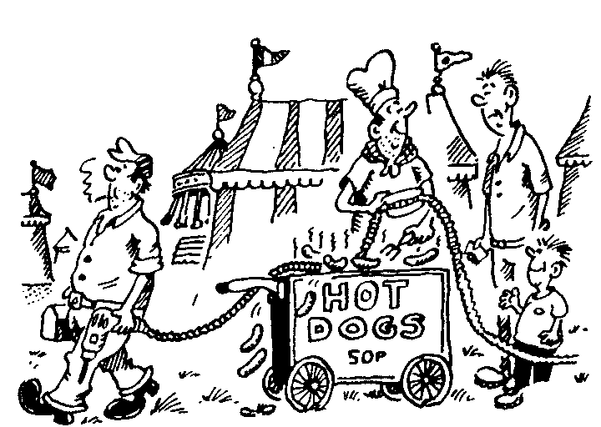
These characteristics must also be borne in mind where installations are in artificial climates in temperate zones including refrigeration plants, cool rooms, hot spots in foundries or near furnaces and ovens etc.

In general terms both flexible and pliable conduit may have a tendency to become brittle at low temperatures, and therefore to lose flexibility and strength. At high temperature there may be a tendency for the product to lose rigidity and form and therefore strength. Flexing and bending tests are carried out at the temperature limits of the product to ensure that this does not happen.
In general use inside buildings, extremes of temperature will not be an issue. However, specifiers/purchasers must take this characteristic into account for specialist application, and where the installation is in hot or cold locations.

Electrical properties

Electrical continuity characteristics relate to metallic and composite systems containing continuous metal.

The tests specified conduit standards BS EN 50086 demonstrate continuity. However, in accordance with the wiring regulations, flexible & pliable conduit may not be used as a primary earth. Conduit systems with electrical insulating characteristics provide an additional level of electrical protection should damage to the internal wiring occur.
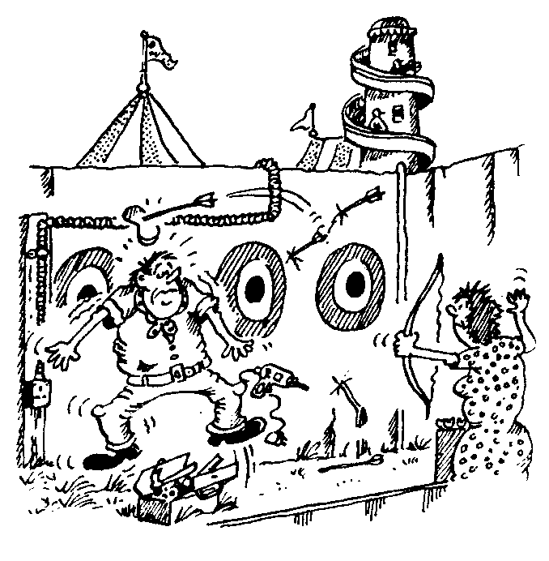

External influences

Resistance to ingress of solid objects

The test contains a six-point scale indicating resistance to ingress of solids. The range is from relatively large objects measuring more than 2.5mm in diameter to ‘dust tight’.
In all installations it is important that objects such as small stones, chippings, wood particles, staples etc do not gain access to the wiring system, especially flexible systems where there may be high and regular levels of vibration or where the conduit is flexing regularly.

Such objects may become lodged between wires resulting in wear to insulation with the consequential risk of system failure. In addition there is a risk that they may travel along a conduit to a junction box where they may damage or short across terminals.
For installations in premises where fine particles are suspended in the atmosphere, extremely rigorous dust proofing will be essential. This will be especially the case where the dust is organic and therefore potentially explosive.

Resistance to Ingress of water
As for solid objects, there is a broad spectrum of protection against the ingress of water. This has an eight point scale. There is no general requirement for protection against water for most indoor applications in buildings such as hotels, offices, hospitals, schools and public buildings. However all of these buildings will have washrooms, kitchens, bathrooms and medical rooms which will need special treatment.
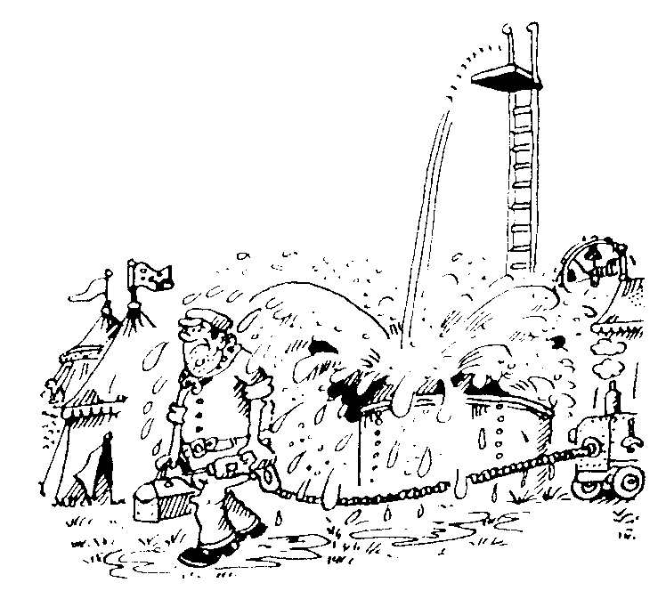

Additionally there is a range of industrial, transport and outdoor uses where water and other liquids become a major hazard. It is because of the diversity of these applications that there is an eight-point scale. Full information on the environment of use is required so that the appropriate conduit system can be specified

Resistance to corrosion

At present the standard addresses the performance of steel products in water vapour (rusting). It is likely that there will be a modification in the future to include degredation of plastics as well as resistance to corrosive agents other than water.
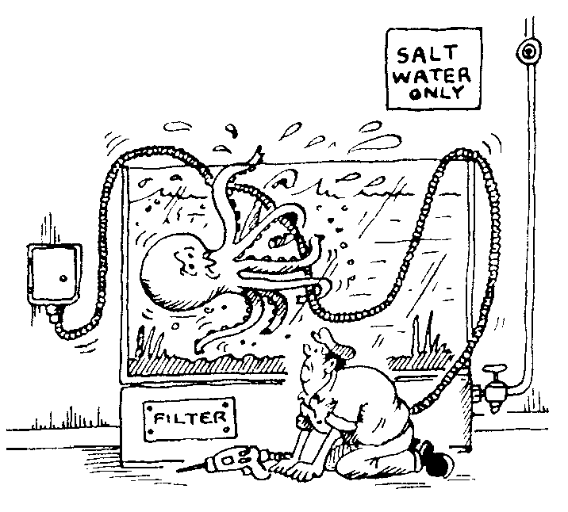

There are four classifications in the resistance to corrosion table ranging from low level (priming paint) to high level (hot dip galvanising and stainless steel).
Clearly the level of protection needed will depend on the application. Buildings will need only a low level of resistance provided due allowance is made for bathrooms and kitchens etc.

The high level of protection will be needed for industrial applications, marine environments and external applications.

Thermal properties
The test used in IEC61386 demonstrates resistance to burning and flame propagation. The product, after subject to a 1kW flame, must self extinguish within 30 seconds after the flame is removed. Systems which are flame propagating must not be used without additional fire protection. All Adaptaflex conduits, for example, with the exception of PPFM pass this test. Additional fire tests and requirements may be needed for specialist applications and areas.
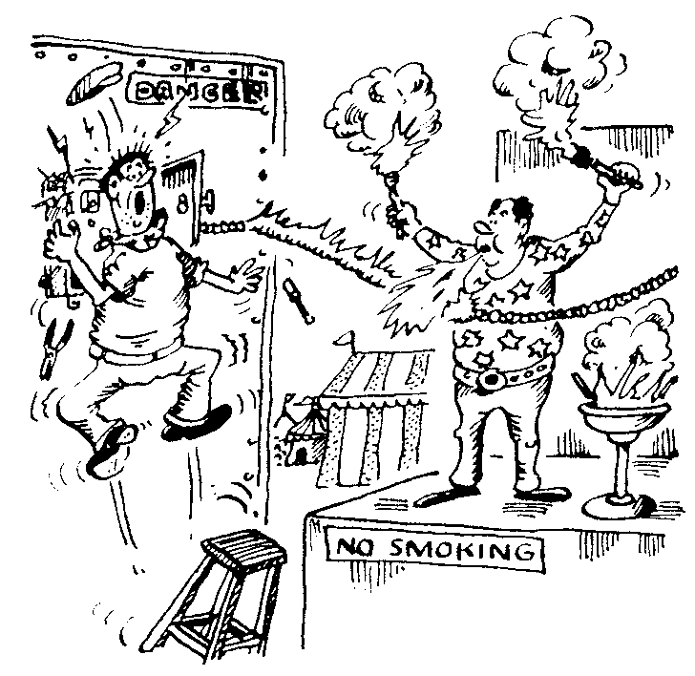

Performance characteristics of conduit systems according to IEC61386

 | 0 | 1 | 2 | 3 | 4 | 5 | 6 | 7
Compression strength (N) | - | V light  125 | Light  320 | Medium 750 | Heavy 1250 | V heavy 4000 | - | -
Impact strength (J) | - | V light  0.5 | Light 1 | Medium  2 | Heavy  6 | V heavy  20 | - | -
Resistance to bending | - | Rigid | Pliable | Pliable Self Recovering | Flexible |  | - | -
Tensile strength (N) | None declared | V light  100 | Light  250 | Medium  500 | Heavy  1000 | V heavy  2500 | - | -
Suspended load (N) | None declared | V light  20 | Light  30 | Medium  150 | Heavy  450 | V heavy  850 | - | --
Minimum Temp (⁰C) | - | +5 | -5 | -15 | -25 | -45 | - | -
Maximum Temp(⁰C) | - | +60 | +90 | ±105 | 4.120 | ±150 | +250 | ±400
Electrical properties | None declared | Provides  continuity | Insulating | Provides continuity + insulating | - | - | - | -
Ingress of Solids (IP) | - | - | - | 3 | 4 | 5 | 6
Ingress of Water (IP) | 0 | 1 | 2 | 3 | 4 | 5 | 6 | 7
Corrosion resistance inside & outside of conduit | None declared | Low/low | Med}med | Med/high | High/high | - | - | -
Resistance to flame Propagation | - | Non-flame Flame propagating | propagating | - | - | - | - | -

Please download the pictures to see tensile, impact and flex rig test equipment, and also a typical environment chamber – as required by the new IEC61386.

Adaptaflex Ltd.,
Station Road, Coleshill,
Birmingham B46 1HT
Tel: 01675 468200
Fax: 01675 464930
Email: sales@adaptaflex.co.uk
Web: www.adaptaflex.com

